Test Execution Document:

As part of the test execution I have tested Test Case: TC002. I have done functional testing, exporatory testing, cross browser testing and automated REST API testing scenarios.

As part of functional testing I have tested test case TC002 and found few bugs also have done a quick exploratory testing to check links and buttons but noticed Contacts screen is showing Error and it’s misspelled and Sell Energy section is under maintenance. Also, have done a quick cross browser testing noticed an issue with eye icon. As part REST API testing task I have automated few scenarios using SpecFlow, RestSharp and C# framework. I found a bug as part of API testing. I have mentioned all the bugs which I have found during my test execution I have mentioned them below.

Please find the scree recording (functional) and html report(REST API BDD scenarios) below for reference!





Bug Report Document for Test Execution and Rest API tasks.

TEST EXECUTION

**Test Case**: **TC002** - **Register a new user.**

**Bug Title**: "Database connection error on user registration".

**Description**: When attempting to register a new account, the system throws a database connection error, preventing the user from completing the registration process.

**Steps to Reproduce**:

1. Navigate to the "Register" page.
2. Enter valid details for below fields.
   * Email
   * Password
   * Confirm Password
3. Click "Submit."
4. Observe the error message.

**Expected Result**: The user should be successfully registered, and a confirmation message should display.

**Actual Result**: The system throws the below error:

**Severity**: Critical (Prevents core functionality, user registration).

**Impact**: Users are unable to register on the platform, severely affecting usability and new user acquisition.

**Evidence**: Please find the screen recording below for the reference!



**Bug Title**: Password visibility toggle (eye icon) missing on Chrome but visible on Edge in the Register page

**Description**: The "eye" icon that allows users to toggle the visibility of the password field is not displayed on Chrome but is visible on Microsoft Edge. This inconsistency can lead to a suboptimal user experience, particularly for users who prefer to view their password during input.

**Steps to Reproduce**:

* 1. Open the **ENSEK Register** page on Google Chrome.
  2. Navigate to the **Password** field.
  3. Observe whether the "eye" icon appears to toggle password visibility.
  4. Repeat the steps using **Microsoft Edge**.

**Expected Result**: The "eye" icon should be consistently displayed across all browsers, including Chrome and Edge, allowing users to toggle the visibility of their password.

**Actual Result**: The "eye" icon is displayed on Microsoft Edge but missing on Google Chrome, preventing users from toggling the visibility of their password on Chrome.

**Severity**: Medium (impacts user experience but not functionality).

**Browser Versions**:

1. Issue occurs on: Google Chrome (version details to be added)
2. Works fine on: Microsoft Edge (version details to be added)

**Evidence**: Attached screenshots comparing the Chrome and Edge browsers.

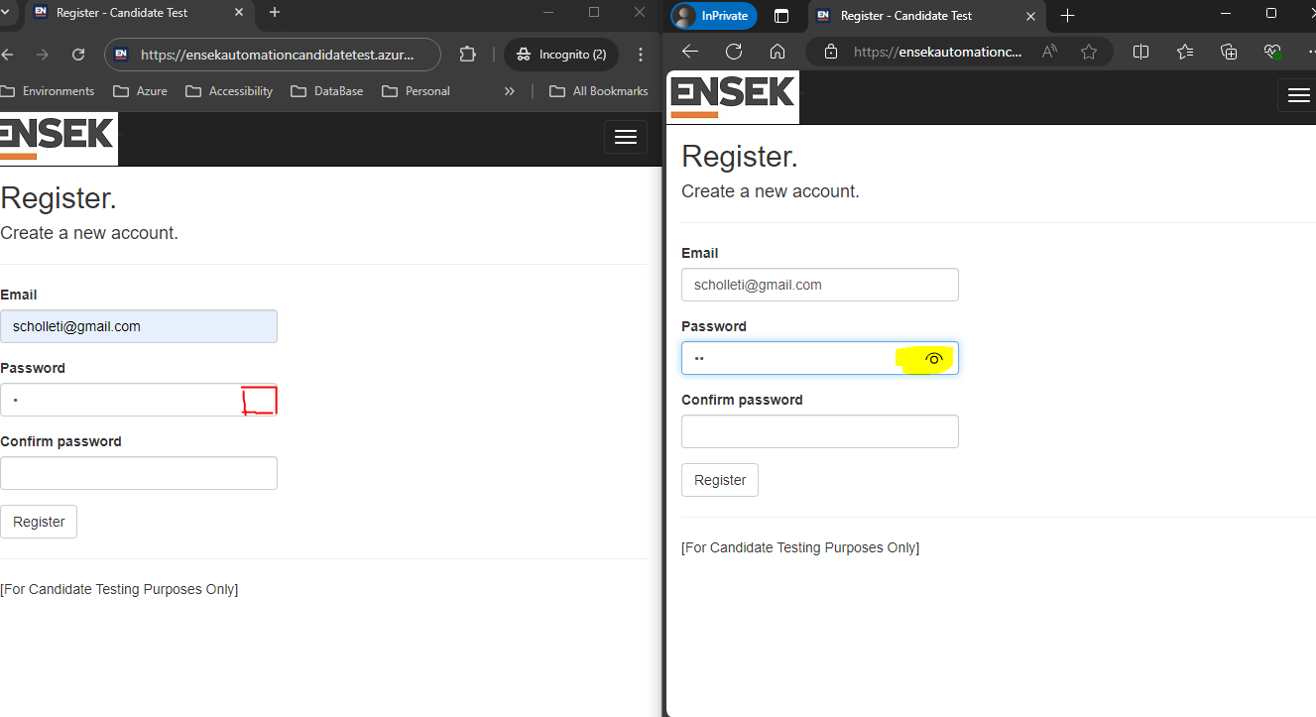

This bug affects the usability of the registration process, as users may struggle to verify their password input on Chrome.

REST API Testing

**Scenario: 01_Reset the test data**

Given User is authorised

When User 'reset' the test data

Then the data should be cleared and reset to default values

**Bug Title**: "Unauthorized error displayed in the response when trying to reset test data via API"

**Description**: When an authorized user attempts to reset the test, an "Unauthorized" error is shown instead of the expected 200 OK status code, and the data is not reset to default values.

**Steps to Reproduce**:

1. Ensure the user is authorized and has the correct API credentials or token.
2. Perform an API call to reset the test data (POST or PUT request, depending on implementation).
3. Observe the response status code.

**Expected Result**: The API should return a 200 OK status code, and the test data should be cleared and reset to default values.

**Actual Result**: The API returns an "Unauthorized" error, preventing the data reset operation.

**Severity**: High (Affects functionality for authorized users, preventing key operations).

**Error Message**: HTTP Status Code: 401 Unauthorized

**Impact**: Authorized users are unable to perform data reset, potentially affecting testing and system functionality.

**Evidence**: Please find the automation status html report for the reference!

Automation Status Report

